MATLAB Homework I

Matlab Code:
#1→ t=-10:0.1:10; % t=-10,-9.9,-9.8 … 9.8,9.9,10
#2→ y=5*cos(0.3*pi*t+1.2*pi); % this is formula (slide 19)
#3→ plot(t,y) % plot is a drawing function. t and y for plot axis.

Screenshot:
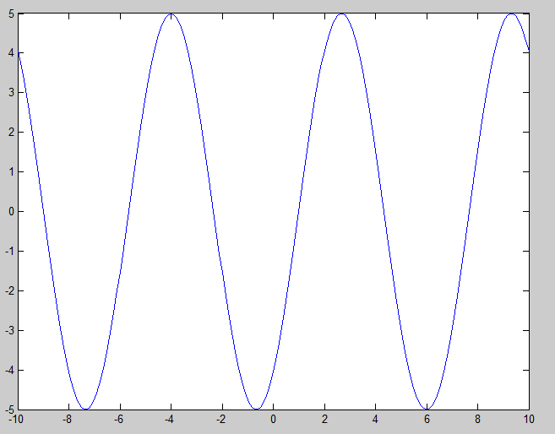

Name and Surname : Sıddık Said AYDOĞAN
Number: 11011052
Date: 30.09.2013

